

**NETWORKING & SYSTEM ADMINISTRATION LAB**

**Experiment No: 7**

**Aim**

Familiarization of the Linux commands.

**Procedure**

**1. READ**

To read the Content of a line to a varible.

**Syntax:-** $ read name

**Output:-**

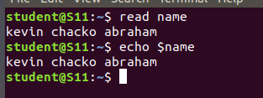

**2. Locate**

To Find the file or Directory in other place.

**Syntax:-** $ locate file1.txt

**Output:-**

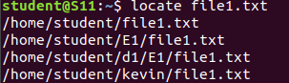

**3.locate –i**

it is used in case insentive search

**Syntax:-** $locate –i file1.txt

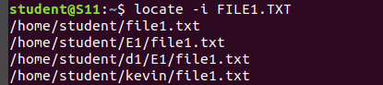

**4.** **Find**

Find the File in a Particular Directory

**Syntax:-** $ find filename

**Output:-**

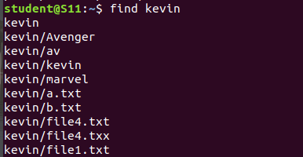

**5. GREP**

Grep command will let you search through all the text in a given File.

**Syntax:-** $ grep “word” filemame

**Output:-**



**6. GREP–A1**

To Display the content and after the result.

**Syntax:-** $ grep –A1 “word” filename

**Output:-**



**7. GREP –B1**

To display the before line of the content.

**Syntax:-** $ paste -d ‘ ‘ file1 file 2 > file3

**Output:-**



**8. GREP –C1**

Before and after lines are displayed.

**Syntax:-** $ paste -d ‘-‘ file1 file2 > file3

**Output:-**



**9. df**

Df is used to get a report on system disc

**Syntax:-** $ df

**Output:-**

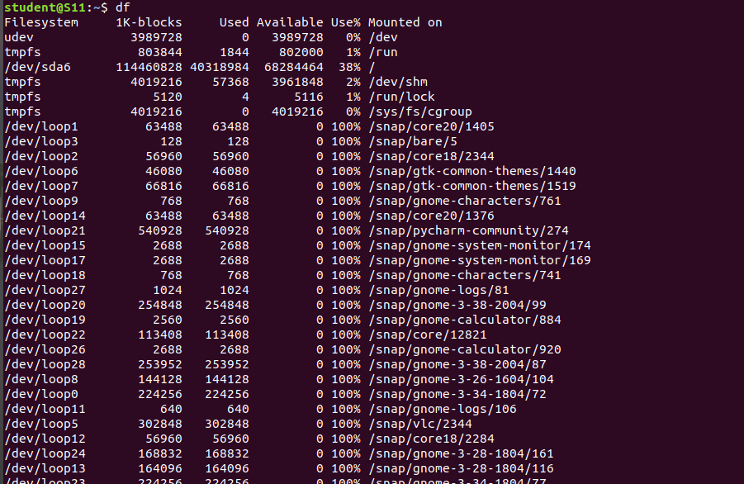

**10. df –m**

how many mega bytes used

**Syntax:-** $ more filename.

**Output:-**

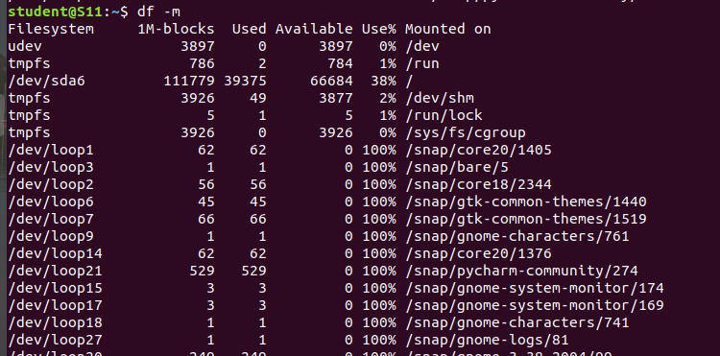

**11. du**

To check how much space a file in a current directory takes

**Syntax:-** $ more -s filename.

**Output:-**

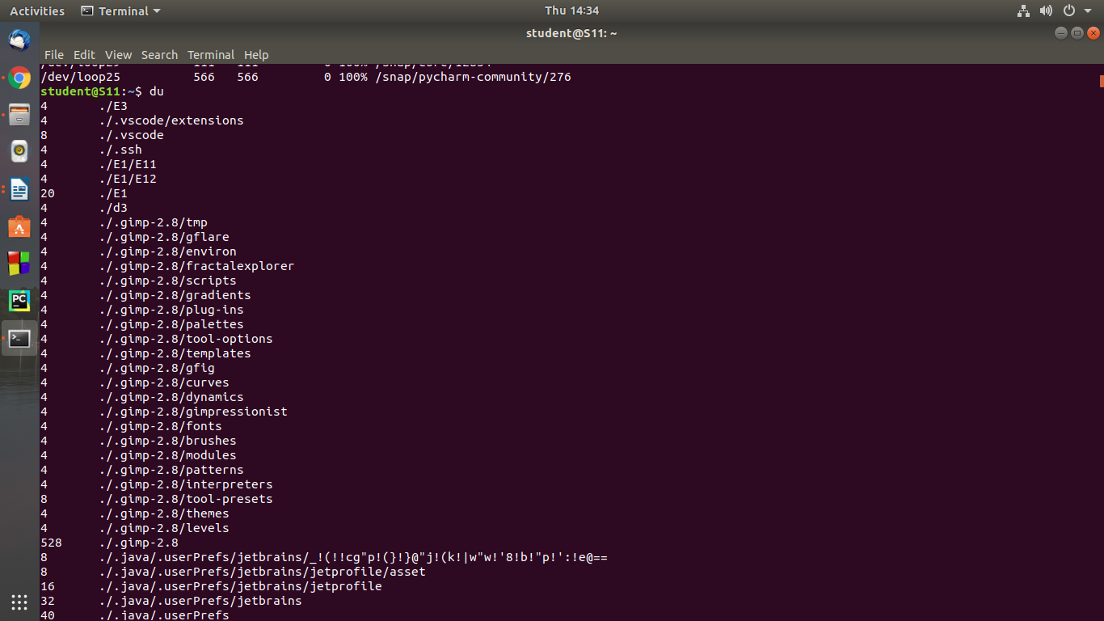

**12. wc**

Word count used for counting purpose

**Syntax:-** $ wc –l filename

$ wc –c filename

$wc –m filename

$wc –w filename

**Output:-**

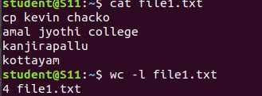







**13.GREP –I**

for an case insenstive search.

**Syntax:-** $ grep –i kanjirapally filename

**Output:-**



**14.GREP –V**

Used inverted search.

**Syntax:-** $ grep –v content filename

**Output:-**

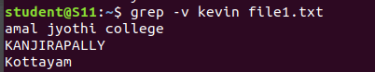

**15.cat filename | grep content**

Highlight word

**Syntax**:-$ cat filename | grep word

**Output:-**

